- A document with the following information:
  - Team 2
  - Joshua, Nathan, Hasan
  - Our product is a glove that will assist visually impaired people while cooking, the goal is to prevent burns while using stoves.
  - Set of photos that show the characteristics of your product
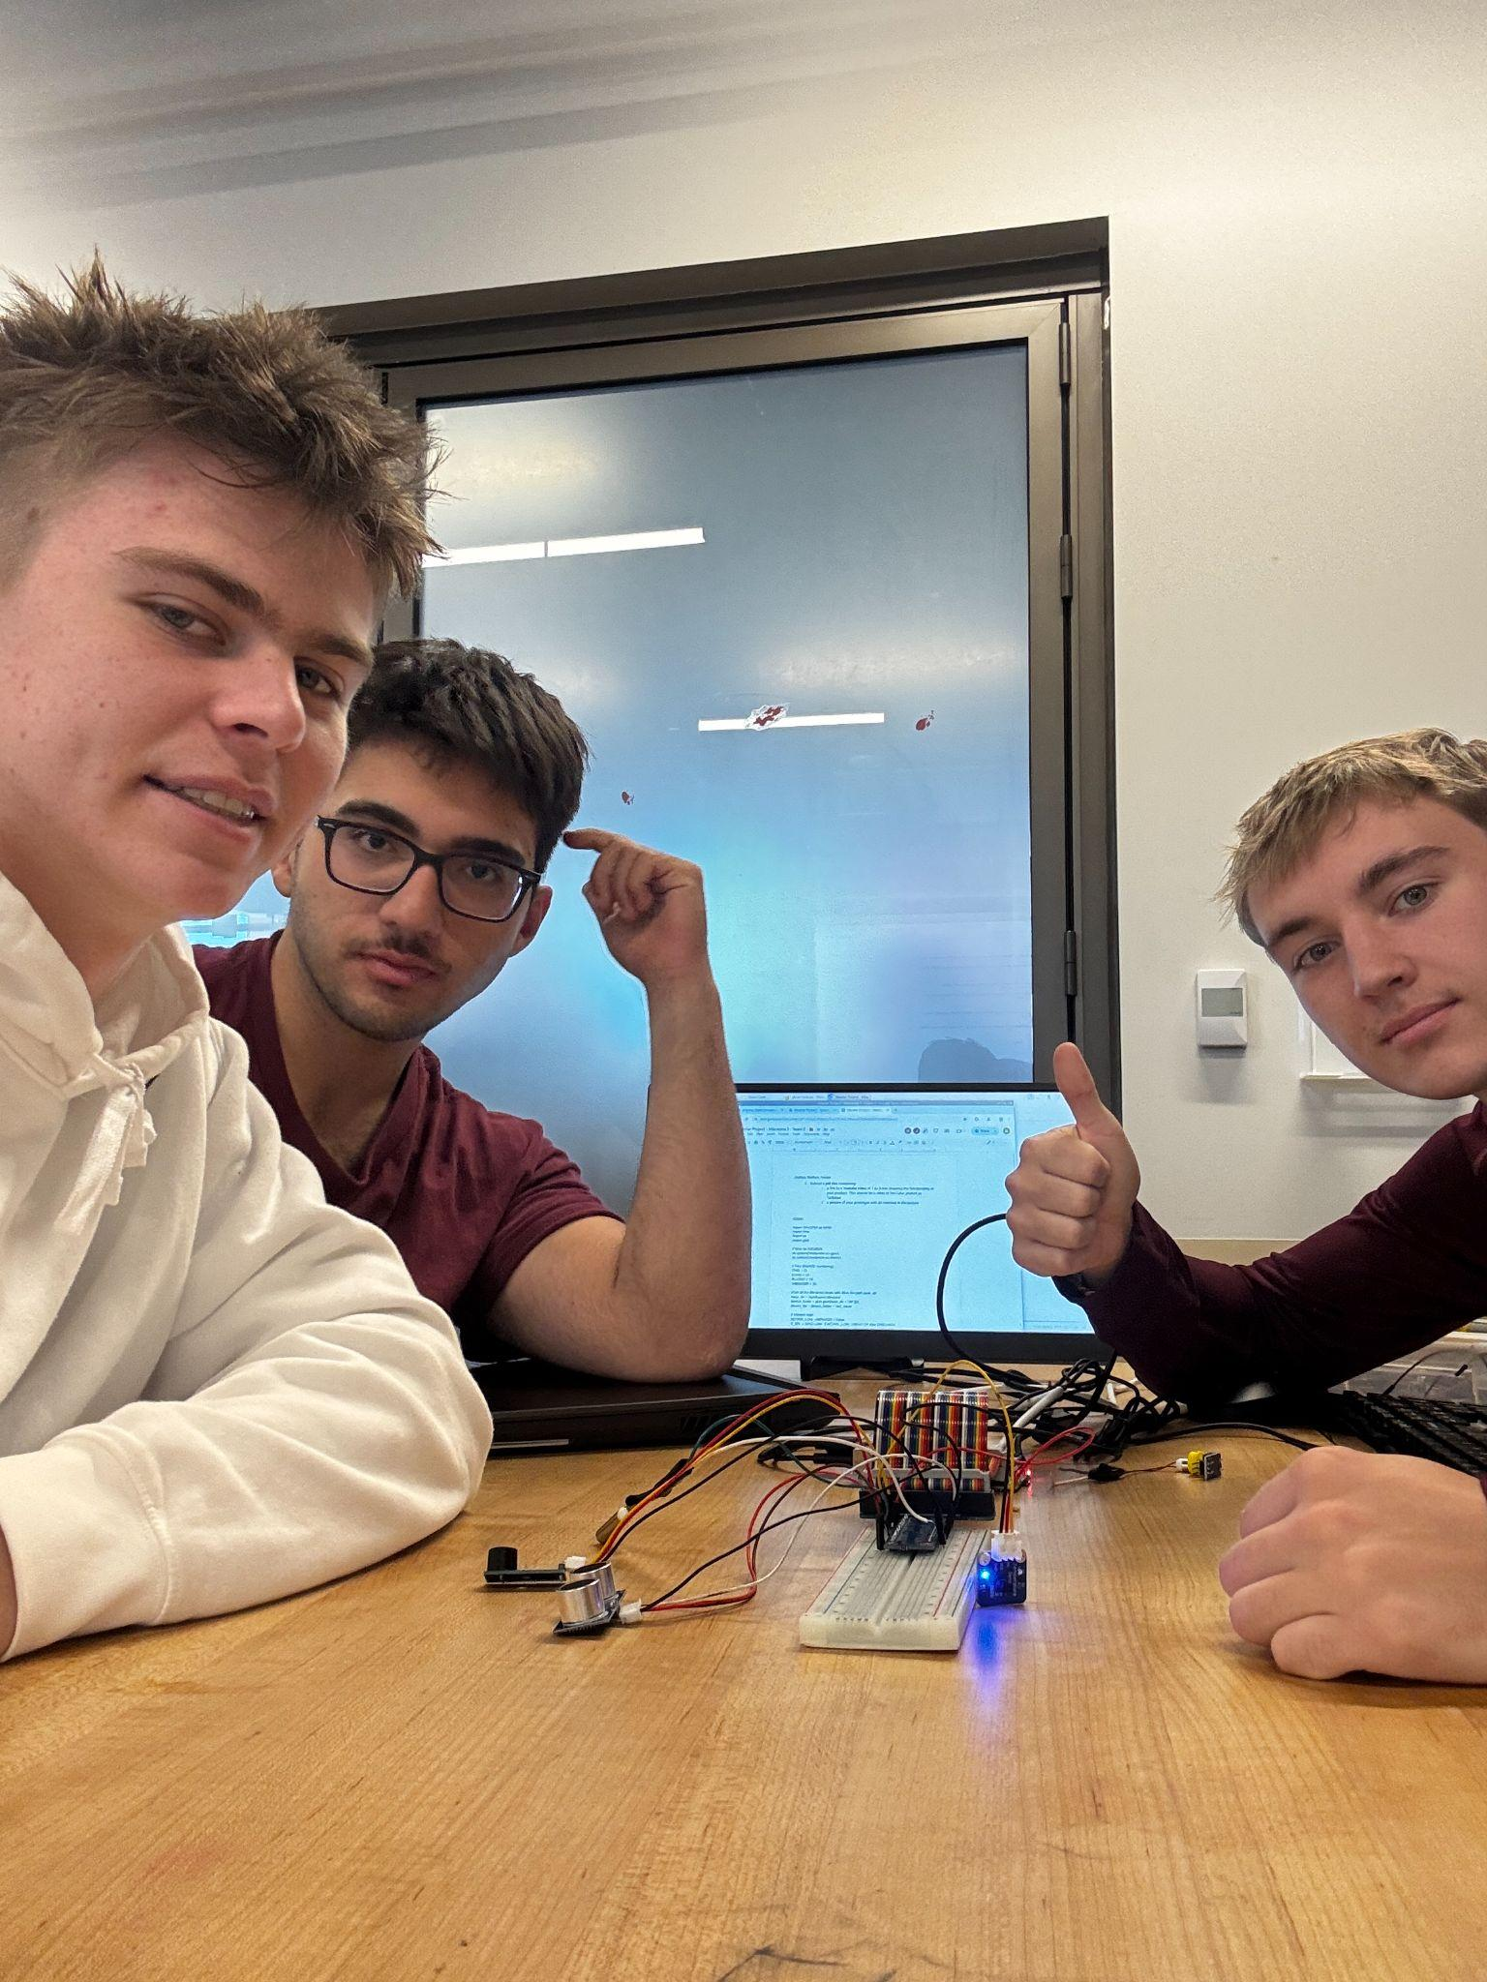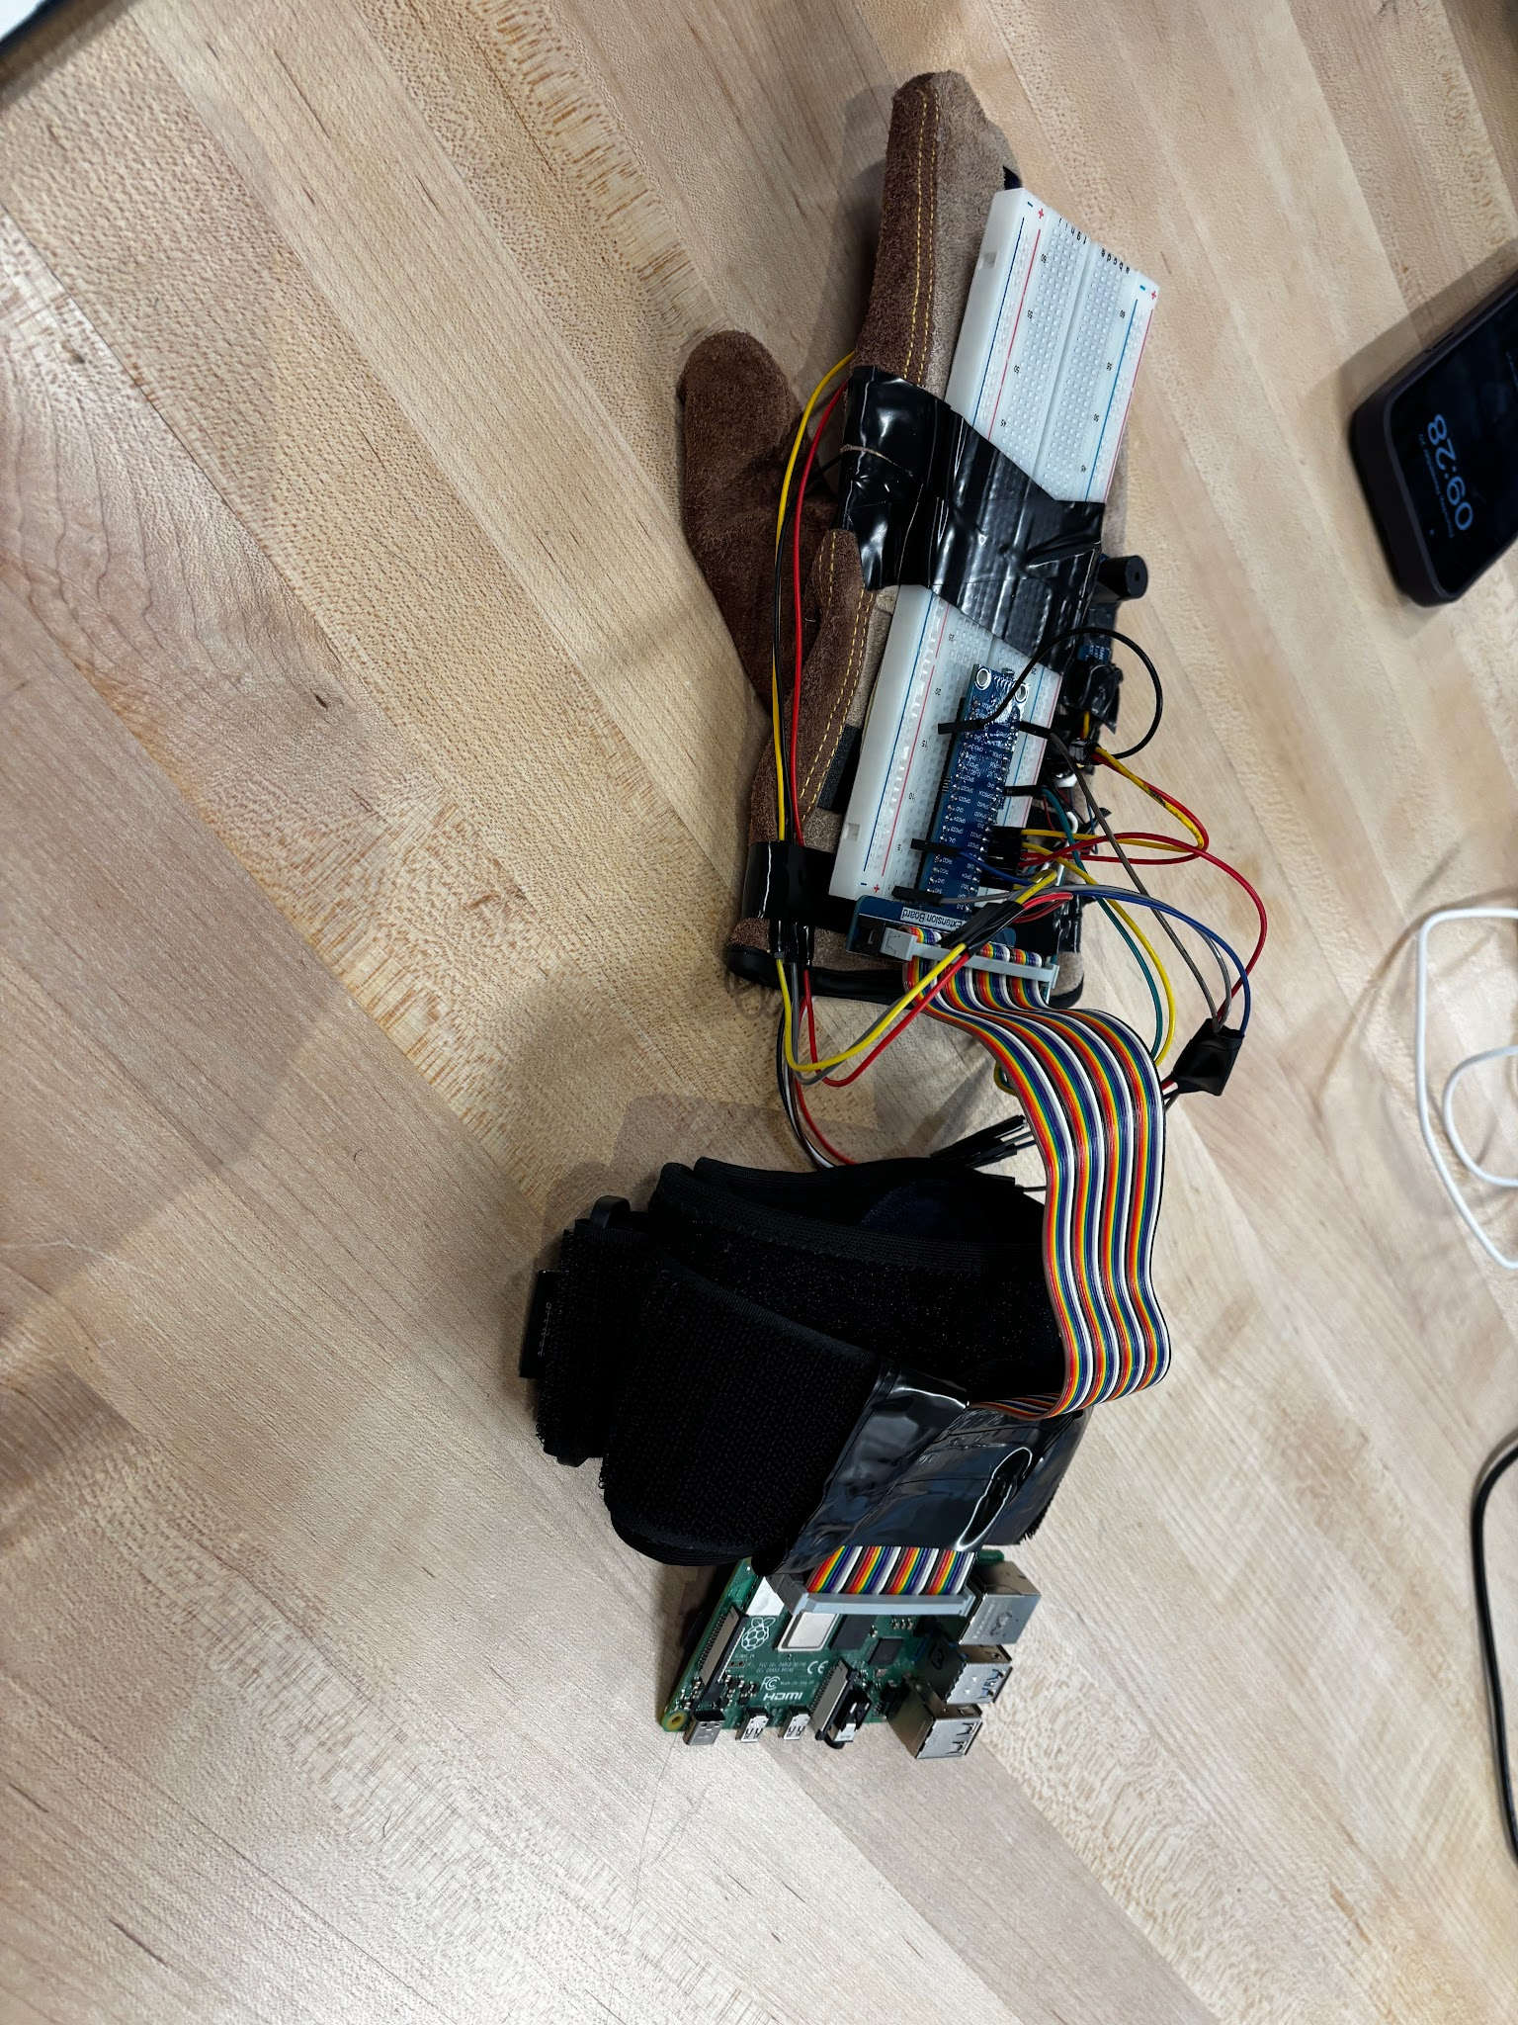

  - Link to the power point presentation
      - https://docs.google.com/presentation/d/1MT5EL28FDyxxdFyVCfmffTF1ZO-74WgCEIJkupAp2Zc/edit?usp=sharing
  - Link to the video showing the functionality of your product
      - https://youtube.com/shorts/FpdcpXi1xc0?feature=share
  - Link to zip file with all your code
      - https://drive.google.com/file/d/1BnqsrG1wjL_FF97E4C8jEGT2dS4wg_nG/view?usp=sharing
- Google Drive with links to all documents related to this project
      - https://drive.google.com/drive/folders/1HyQxK-qyNuSznAGOpL7HTcDUWFeQbdOk?usp=sharing

